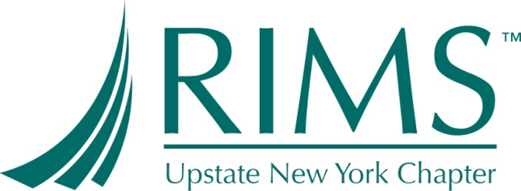

Upstate NY Chapter of
Risk Management Insurance Society (RIMS)
Annual Conference Sponsorship Application
___________________________________________________________________________________________________________

In applying for this sponsorship, it is strongly recommended that you print the checklist below and check off the requirements completed. The first step to completing the RIMS sponsorship application process is to determine your eligibility.

DESCRIPTION:

The Upstate Chapter of the Risk and Insurance Management Society (RIMS) intends to sponsor one qualified candidate to this year’s annual conference. Sponsorship includes up to $2300.00 toward the following:

- Air-fare to conference, transportation to and from airport.
- RIMS approved accommodation.
- Annual Conference fee.

PURPOSE:

The purpose of this sponsorship is to promote the interest in and development in the field of risk management and insurance practices.

QUALIFICATIONS:

- You are employed by a firm headquartered in Upstate NY.
- You are NOT employed by a company that provides services to the risk management and or insurance function of another firm.
- You are a current full time employee.
- Member of Upstate NY Chapter of RIMS or in the process of becoming a member
- Involved in risk management and/or insurance function with your employer.
- Able to travel to this year’s site of RIMS Annual Conference .Are of 18 years of age or older.
- Did not receive this sponsorship last year.
- Agree to attend Upstate NY chapter of RIMS meeting on March 20, 2012 and on May 15, 2012 to share the experience with the Chapter.
- Document experience at the conference for an article to be published in the Chapter newsletter.

Upstate NY Chapter of
Risk Management Insurance Society (RIMS)
Annual Conference Sponsorship Application
___________________________________________________________________________________________________________

The application for a sponsorship becomes complete and valid only when you have completed the following:

Requirements:
Applications completed & received by 2/6/12.
Verify Qualifications on page 1 of this application.
Attach resume or description of professional; accomplishments and responsibilities.
Certify that application is complete with the terms and conditions of this application (Qualifiers).

Last Name: _____________________First Name: ____________________Middle:____
Company Name: _________________________________________________________
Title: ___________________________________________________________________
Work Address: __________________________________________________________
City: ________________________ State: _______________________ Zip: _____
Email Address: __________
Telephone: (_____) ________________

Questions should be directed to:

Karen Benedetto (585) 678-7137.
Applications may be e-mailed:
karen.benedetto@cbrands.com

After February 6, applications will not be processed.
"Notice of Non-Discrimination Policy”
The NY Chapter of RIMS does not discriminate in any manner contrary to law or justice on the basis of race, color, sex, age, religion, sexual orientation, national origin, disability or veteran's status in the administration of its educational, charitable, scientific or other policies or programs."

Upstate NY Chapter of
Risk Management Insurance Society (RIMS)
Annual Conference Sponsorship Application
___________________________________________________________________________________________________________

QUESTIONS:

1) Are you currently involved in the risk management and or insurance function at your company? Y ____ N _____

Please explain function detail.
_____________________________________________________________________________________________________________________________________________________________________________________________________________________

2) Reasons for applying for this sponsorship.

_____________________________________________________________________________________________________________________________________________________________________________________________________________________

3) List career and/or company goals as they relate to risk management.

_____________________________________________________________________________________________________________________________________________________________________________________________________________________

4) Has your company sent employees to RIMS Annual Conference in the past? Y___ N____

If yes, when? ______________

5) Is your company sending a representative this year? Y_____ N _____

6) Have you taken any Risk Management courses or attended any seminars?

Y ____ N ______ If yes, please explain:

Upstate NY Chapter of
Risk Management Insurance Society (RIMS)
Annual Conference Sponsorship Application
___________________________________________________________________________________________________________

Potential recipients are requested to submit a typed essay describing how this sponsorship can assist you. Please type your full name and company name at the top of the page.

How will receiving this sponsorship improve or enhance your career?

____________________________________________________________________________________________________________________________________________________________________________________________________________________________________________________________________________________________

CERTIFICATION:

In submitting this application, I certify that the information is complete and accurate to the best of my knowledge, and agree to comply with Upstate NY Chapter of RIMS. I understand that falsification of qualifications stated in this document or any false information given, will result in termination of this sponsorship granted.

In submitting this application, I hereby give permission to release information to Nation RIMS Conference.

If selected to receive this sponsorship, I agree to the use of my name, likeness and information contained in my application in any media form and type of publication, including annual reports and newsletters. I grant Upstate RIMS any and all rights to said use without compensation.

Signature: ________________________________________________

Date: ___________________________________________________

"Notice of Rights Policy”

The NY chapter of RIMS reserves the right to review all applications to ensure all information if verified and guidelines have been met before granting benefits of the stated purpose of the Annual Conference Sponsorship.

